GROUNDHOG SHADOW DAY – SAMPLE AGENDA
(a great model for engaging a large organization in a cohesive event)
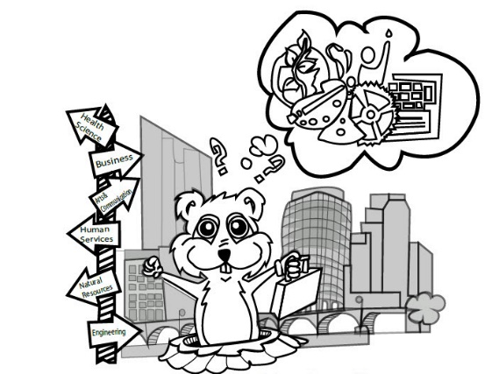
Time | Activity
9:00 – 9:15am | Arrive and Meet Host:  Perhaps given name badge and greeted by employee mentor (helps if there is a central point person welcoming students who can check them in and point out their mentors)
9:15-9:45am | Company introduction and Career Welcome:  Students and mentors will sit together and listen to a brief address from a company representative describing some general information about the company and perhaps discussing a bit of “What should I be doing to prepare myself for professional success down the road?” advice
9:45–12:15 pm | Time with Mentor:  During this time the student and mentor would break off from the larger group so that the student can spend some time asking directed questions about the profession they are more excited to learn about. Mentors would show off their individual work spaces, discuss current projects, introduce them to other coworkers, share information about his/her career progression and try and demonstrate to the student what makes up their work flow.
12:15-12:45 pm | Lunch with Host:  Return to common space and eat as a large group
12:45-1:15 pm | Speed Networking:  Opportunity for students to briefly hear from a variety of mentors within the company. Mentors would sit at a table and students would rotate around every 5 minutes or so to hear about the different roles and responsibilities that exist within the organization. Mentors might bring a few ‘artifacts’ from their job area to help articulate their role.
1:15 – 2:00pm | Tour and Send-off:  Students would get a brief tour of the facility and say farewell and thank you to mentors.  Contact the Career Readiness for more sample schedules and hosting ideas at careerexploration@kentisd.org, or Krista Harmon, 616-365-2369.

