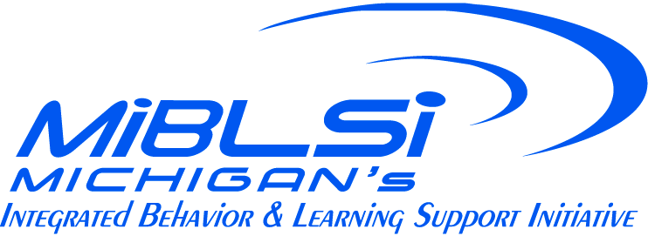

Building Leadership Team Responsibilities
The team consists of five to seven staff members. A building administrator and an MTSS coach are required. Other suggested members include 1) an individual with behavior expertise; 2) an individual with reading expertise; 3) a representative from special education; 4) a representative from general education; 5) a representative from the school improvement team; 6) representatives from different grade levels.

Team plans and coordinates implementation efforts:
- Annual implementation plan is developed and is embedded within the school improvement process
- Team obtains staff consensus around implementation plan.
- Team reviews progress toward annual plan monthly
- Team coordinates implementation activities based on program quality and student outcome data
- Team “makes room” for implementation by combining and braiding current school initiatives
- Team works to allocate resources to support implementation with fidelity
- Team works to develop a process for student access to Tier II-III supports and effectiveness is monitored

Team Communicates implementation efforts to building staff, school community and district administration:
- Implementation plan, with common vision for schoolwide supports is shared with staff and school community
- Implementation status updates are provided at monthly staff meetings.
- Feedback is gathered from staff by leadership team
- An acknowledgement system is implemented to encourage staff application of MTSS skills
- A plan for professional development is provided and implemented for staff.
- There is an orientation process for new staff to acquire necessary skills for implementing schoolwide supports
- Coaching supports are provided to help staff with implementation issues
- Local (building-based) expertise is identified and provides technical assistance to staff
- Team communicates areas of success and need via the principal (who is a team member) and / or individual(s) providing district MTSS coordination so successes can be celebrated and needs can be addressed in a timely way.

Team develops and /or accesses resources for implementation purposes
- Materials are specifically created (e.g., behavior teaching schedules, behavior lesson plans, schedule for grade levels to have an uninterrupted 90-minute reading block) for use by staff
- Implementation materials are easy to use and relevant to implementation plan
- A master copy of implementation materials and tools are placed in a specified location for reference
- Staff handbook includes schoolwide support goals and strategies
- Materials and resources are made available for Tier II – III supports

